SCCSA Heading and Concussion Guidelines.

Background
This document sets out the guiding principles developed by AIS and The FA, and provides general advice regarding:
- Recommended heading guidance for training sessions for SCCSA Clubs, coaches and players
- The management of concussion in SCCSA
These Guidelines are of a general nature only. Individual treatment will depend on the facts and circumstances specific to each individual case. These Guidelines are not intended as a standard of care and should not be interpreted as such.
These Guidelines have been soured from Australian Concussion Guidelines for Youth and Community Sport and The FA Heading Guidance.

CONCUSSION
Concussion is a brain injury resulting in a disturbance of brain function. A concussion occurs through a collision with another person or object where biomechanical forces to the head, or anywhere on the body transmit an impulsive force to the head/brain.
Concussion is often an evolving injury, with symptoms changing over hours or days following the injury. There are often adverse effects on balance and cognitive function. Recovery times following concussion vary between athletes.

1.1 SIGNS OF CONCUSSION
Immediate visual indicators of concussion include:
(a) Loss of consciousness or responsiveness;
(b) Lying motionless on the ground/slow to get up;
(c) A dazed, blank or vacant expression;
(d) Appearing unsteady on feet, balance problems or falling over;
(e) Grabbing or clutching of the head
(f) Impact seizure or convulsion

Concussion can include one or more of the following symptoms:
(a) Symptoms: Headache, dizziness, “feeling in a fog”.
(b) Behavioural changes: Inappropriate emotions, irritability, feeling nervous or anxious.
(c) Cognitive impairment: Slowed reaction times, confusion/disorientation- not aware of location or score, poor attention and concentration, loss of memory for events up to and/or after the concussion.

The Pocket Concussion Recognition Tool may be used to help identify a suspected concussion (see ‘Resources’ below).

1.2 REMOVE FROM PLAY “Remember, if in doubt, sit them out”
Immediately following a suspected concussion, it is important to exclude ‘red flags’ (signs that suggest the athlete should go straight to hospital). Once ‘red flags’ have been excluded, the athlete should be referred to a health care practitioner.

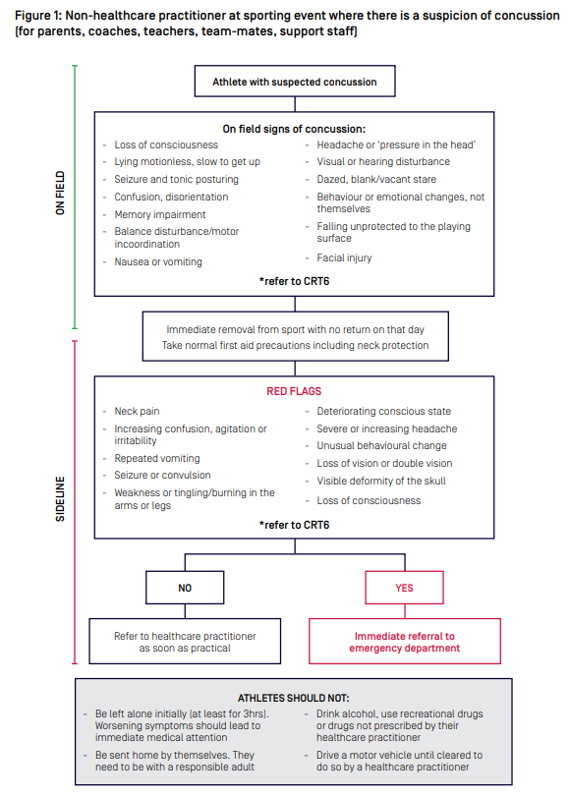
Return to sport and learning activities commences with a short period of rest of 24-48 hours, followed by a gradual return to sport and/or learn process.

1.3 RETURN TO PLAY
The risk of complications from concussion is increased if a player is permitted to return to sport before they have fully recovered.
The graded return to sport framework (GRTSF) for community and youth assists athletes/ coach/parents/teachers with concussion management through the recovery process and time frames for a safe return to sport/learn.
The AIS return to sport protocol for community and youth sport includes;
- Introduction of light exercise after an initial 24-48 hours of relative rest
- Several checkpoints to be cleared prior to progression.
- Gradual reintroduction of learning and work activities.
- At least 14 days symptom free (at rest) before return to contact/collision training.
- A minimum of 21 days until the resumption of competitive contact/collision sport.
- Return to learn and work activities should take priority over return to sport..

1.4 CONCUSSION RESOURCES
A) Pocket Concussion Recognition Tool, found here: http://bjsm.bmj.com/content/47/5/267.full.pdf
B) SCAT 5 – Sport Concussion Assessment Tool – 5 th Edition, found here: http://bjsm.bmj.com/content/bjsports/51/11/851.full.pdf
C) Child – SCAT5- Sport Concussion Assessment Tool (for children ages 5-12 years), found here: http://bjsm.bmj.com/content/bjsports/early/2017/04/28/bjsports-2017- 097492childscat5.full.pdf
D) Australian Concussion Guidelines for Youth and Community Sport, found here: 37382_Concussion-Guidelines-for-community-and-youth-FA-acc.pdf
E) Graduated Return to Sport Framework found here: Graded return to sport framework for community and youth (concussioninsport.gov.au)
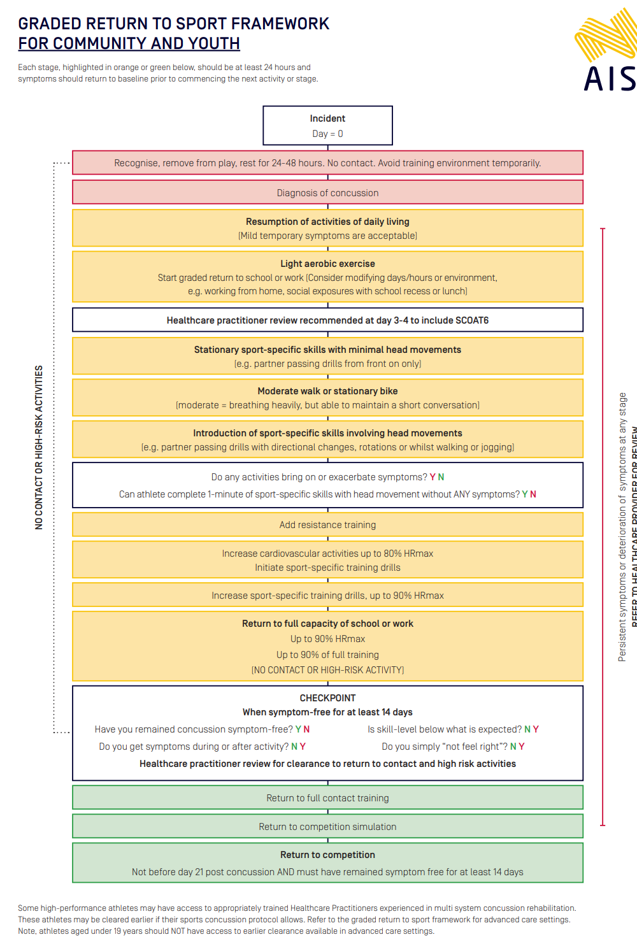

HEADING GUIDANCE
The Following will provide SCCSA clubs, coaches and players with the recommended heading guidance for training sessions only. The guidance does not make any changes to the way matches are played.

2.1 OUTLINE
• No heading in training in the foundation phase (U6 to U11)
• Graduated approach to heading training for children in the development phase (U12 to U16/17)
• Required ball sizes for training and matches for each age group
• Don’t over inflate the balls: use the lowest pressure authorised by the laws of the game.
• No changes to heading in matches, taking into consideration the limited number of headers in youth games

2.2 HEADING IN TRAINING
AGE GOUP | Heading Frequency
Under 6 to Under 11 | Heading should not be introduced in training sessions at this age.
Under 12 | Heading remains a low priority.  1 session per month & max 5 headers  Use of light balls, using self-serve or short distance.  These limited sessions should introduce the technique and should always be unopposed.
Under 13 | Heading remains a low priority.  1 session per week and max 5 headers  Use of light balls  These limited sessions should introduce the technique and should always be unopposed.
Under 14 to Under 16/17 | Heading remains a low priority.  1 session per week and max 10 headers  Use of light balls  Players can be introduced to the basic concepts in training with limited repetition.  Coaches should use a variety of distances relative to the game at this age.
U18 | Heading drills should be reduced as far as possible, taking in to consideration the heading exposure in matches.  Should use a variety of heading situations players will experience.  The introduction of contested headers.  Use of match balls may be used in the session
Source: FA Heading Guidance

2.3 RESOURCES

England Football Heading in Football- https://www.englandfootball.com/participate/learn/Brain-Health/Heading-in-Football
The FA Heading Guidance- https://www.thefa.com/-/media/thefacom-new/files/rules-and-regulations/2021-22/heading-guidance/youth-heading-guidance-chart.ashx
UEFA Heading guidelines for youth Players- https://www.uefa.com/MultimediaFiles/Download/uefaorg/Medical/02/64/21/56/2642156_DOWNLOAD.pdf

